Program 2

CS 355

Connor Elliott and Logan Risner

Functionality of Program

This time, we modified Program 1 to instead more realistically shuffle a pack of cards. In real life shuffling, two or more cards from the same half may be taken before one or more from the other half has. To apply this to our program, we first use a random variable to non deterministically choose a deck. One of the variables chooses a deck with the probability of .5 each time. We create another variable where the probability changes based off of the size of the sub deck relative to the total number of cards that are still available. We use the same arrays and loops from Program 1 to use as our deck of cards and shuffle methods. At the end of the program, the value of r and the iteration count are added to arrays which are then plotted onto a scatter plot using matplot.lib.

Questions

**First Run:**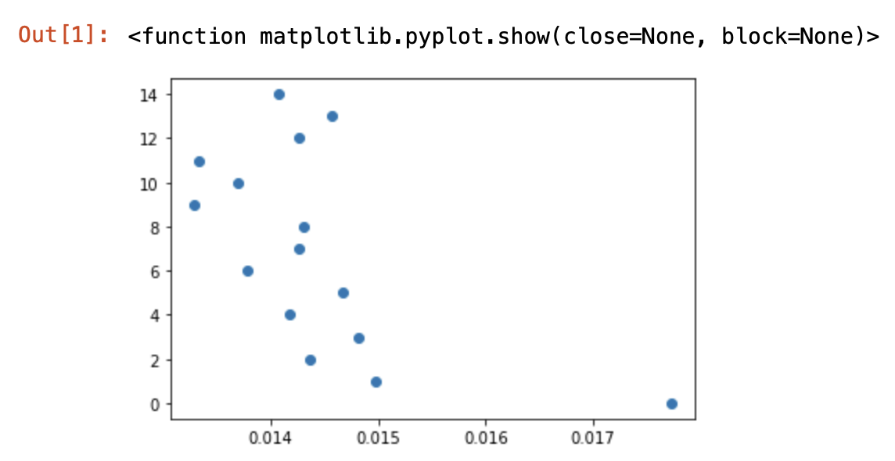

1.

The correlation coefficient is closest to 0 at shuffle 9 so the deck is the most random.

2. No, the cards do not return to original order.

3. No

4. It would take an unnecessarily large number of shuffles to get the cards back in original order.

**Second Run:**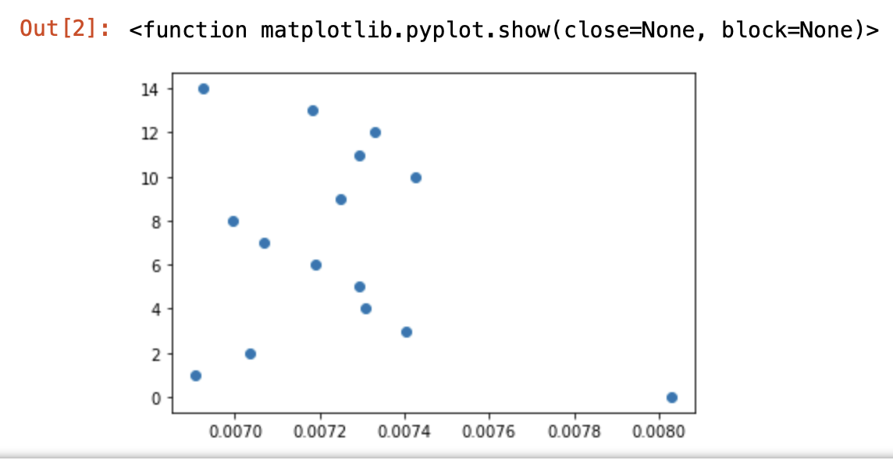

1.

The correlation coefficient is closest to 0 at shuffle 1 so the deck is the most random

2. No, the cards do not return to original order.

3. No

4. It would take an unnecessarily large number of shuffles to get the cards back in original order.

**Third run:**

1.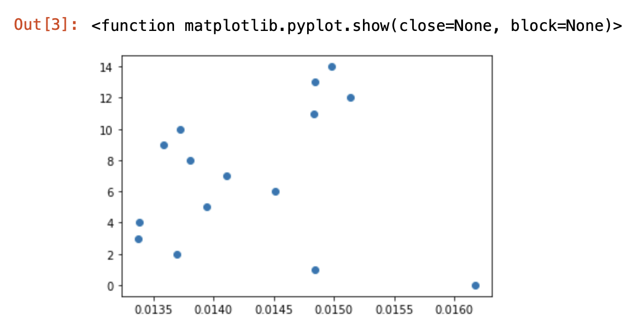

The correlation coefficient is closest to 0 at shuffle 3 so the deck is the most random

2. No, the cards do not return to original order.

3. No

4. It would take an unnecessarily large number of shuffles to get the cards back in original order.

**Fourth Run:**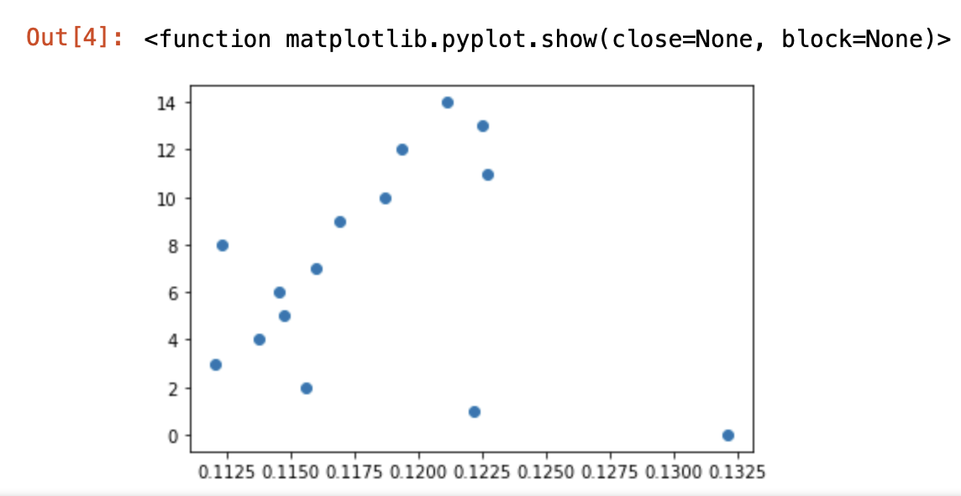

1.

The correlation coefficient is closest to 0 at shuffle 3 so the deck is the most random

2. No, the cards do not return to original order.

3. No

4. It would take an unnecessarily large number of shuffles to get the cards back in original order.